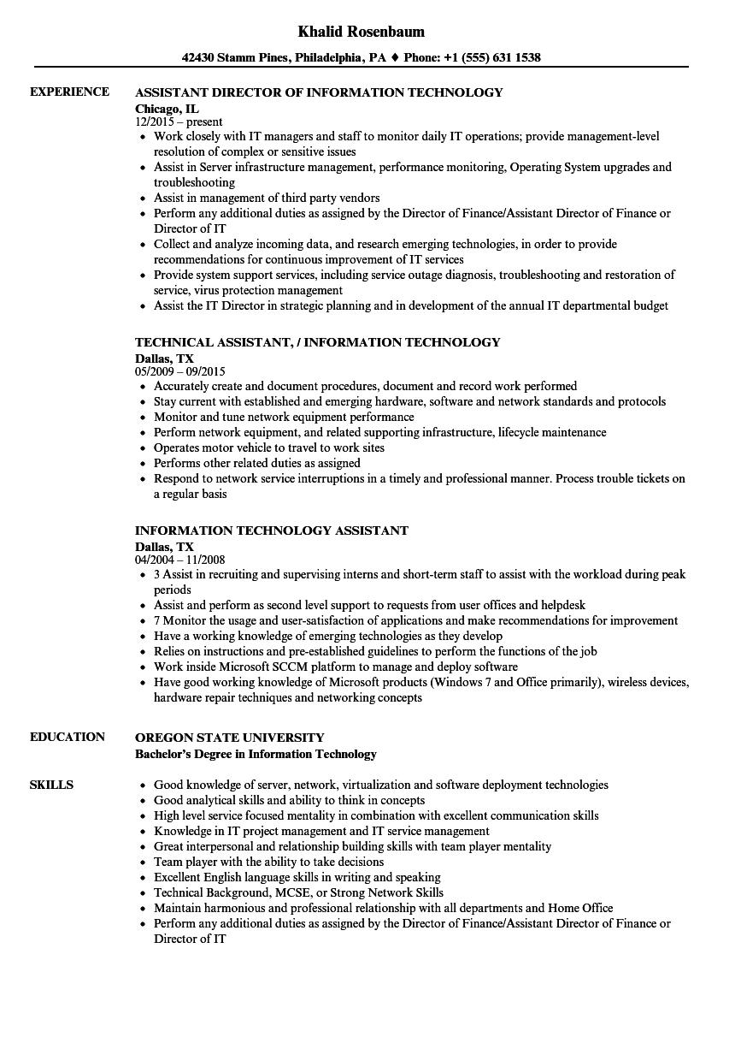
EXPERIENCE
Khalid Rosenbaum
42430 Stamm Pines, Philadelphia, PA ♦ Phone: +1 (555) 631 1538
ASSISTANT DIRECTOR OF INFORMATION TECHNOLOGY
Chicago, IL 12/2015-present
• Work closely with IT managers and staff to monitor daily IT operations; provide management-level resolution of complex or sensitive issues
• Assist in Server infrastructure management, performance monitoring, Operating System upgrades and troubleshooting
• Assist in management of third party vendors
• Perform any additional duties as assigned by the Director of Finance/Assistant Director of Finance or Director of IT
• Collect and analyze incoming data, and research emerging technologies, in order to provide
recommendations for continuous improvement of IT services
• Provide system support services, including service outage diagnosis, troubleshooting and restoration of service, virus protection management
• Assist the IT Director in strategic planning and in development of the annual IT departmental budget
TECHNICAL ASSISTANT, / INFORMATION TECHNOLOGY
Dallas, TX
05/2009 - 09/2015
• Accurately create and document procedures, document and record work performed
⚫ Stay current with established and emerging hardware, software and network standards and protocols
• Monitor and tune network equipment performance
• Perform network equipment, and related supporting infrastructure, lifecycle maintenance
• Operates motor vehicle to travel to work sites
• Performs other related duties as assigned
• Respond to network service interruptions in a timely and professional manner. Process trouble tickets on a regular basis
INFORMATION TECHNOLOGY ASSISTANT
Dallas, TX
04/2004 - 11/2008
⚫ 3 Assist in recruiting and supervising interns and short-term staff to assist with the workload during peak periods
• Assist and perform as second level support to requests from user offices and helpdesk
⚫ 7 Monitor the usage and user-satisfaction of applications and make recommendations for improvement
• Have a working knowledge of emerging technologies as they develop
• Relies on instructions and pre-established guidelines to perform the functions of the job
• Work inside Microsoft SCCM platform to manage and deploy software
• Have good working knowledge of Microsoft products (Windows 7 and Office primarily), wireless devices, hardware repair techniques and networking concepts
EDUCATION
SKILLS
OREGON STATE UNIVERSITY
Bachelor's Degree in Information Technology
Good knowledge of server, network, virtualization and software deployment technologies
• Good analytical skills and ability to think in concepts
⚫ High level service focused mentality in combination with excellent communication skills
• Knowledge in IT project management and IT service management
• Great interpersonal and relationship building skills with team player mentality
⚫ Team player with the ability to take decisions
• Excellent English language skills in writing and speaking
• Technical Background, MCSE, or Strong Network Skills
• Maintain harmonious and professional relationship with all departments and Home Office
• Perform any additional duties as assigned by the Director of Finance/Assistant Director of Finance or Director of IT

